Name: ________________________________________ Date: ____________________________

PreCalculus: Calculus Intro Unit – HW C6-3 Visca

In Exercises 1–10, find the indefinite integral.

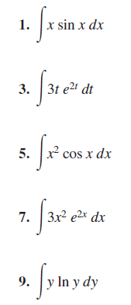

In Exercises 17–20, use parts and solve for the unknown integral.

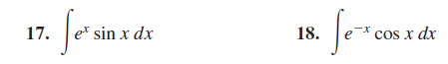

In Exercises 21–24, use tabular integration to find the antiderivative.

